**PiEEG. Introduction**

1. **RaspberryPi4,5 (Pi4,5) install Raspbian operation system**

<https://www.raspberrypi.com/software/>

1. **Connect PiEEG directly to RaspberryPi4 via GPIO40**

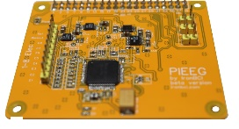 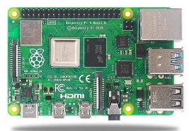 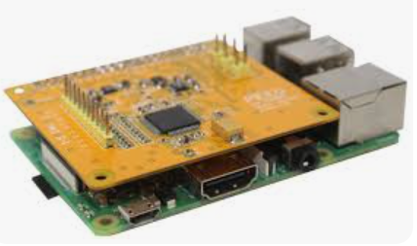

1. **Connect camera screen via micro-HDMI, keyboard and mouse**

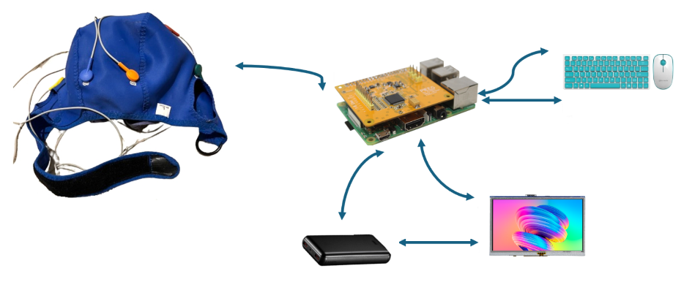

1. **Launch raspberry Pi.**

**Install python IDLE to RaspberryPi**

Step 1

Open a terminal window from Raspberry Pi.

Step 2

Type following command in terminal.

*sudo apt-get install python3*

Step 3

Type following command in terminal.

*sudo apt-get install idle3*

1. **install necessary libraries via pip for Python Idle**

open terminal and install the next libraries

**Pi4**

sudo pip3 *install spidev*

sudo pip3 *install matplotlib*

sudo pip3 *install RPi.GPIO*

sudo pip3 *install scipy*

**Pi5**

sudo pip3 *install RPi.GPIO*

sudo pip3 *install matplotlib*

sudo pip3 *install scipy*

sudo pip3 install gpiod

1. **after that launch the script**

<https://github.com/pieeg-club/PiEEG/blob/main/1.GUI/1.8_ch_Pi4.py>

1. **LED should be ON**

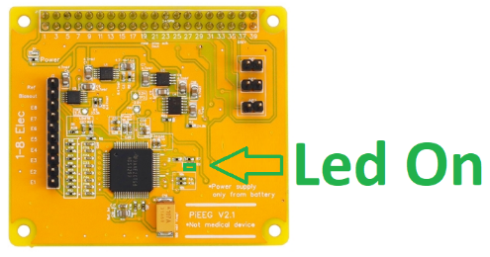

1. **Launch the script**

**Pi4**

<https://github.com/pieeg-club/PiEEG/blob/main/1.GUI/1.8_ch_Pi4.py>

**Pi5**

<https://github.com/pieeg-club/PiEEG/blob/main/1.GUI/1.8_ch_Pi4.py>

and you receive the graph, data in real-time

